**Group member (3 persons)**

Jirayu Petchhan

Tanaporn Chaivutitorn

Supichar Ta.

**Exercise**

Do all these:

1. Create a transaction with invalid signature

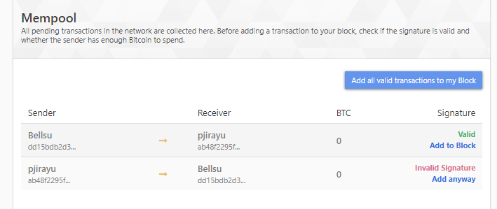

1. Create a transaction with insufficient balance but mine it anyway. What happens?

Insufficient fund

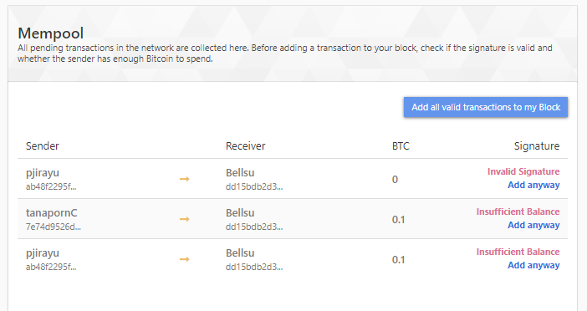

1. Create a transaction from A to B; observe the mempool in other miners, select one of the miners to mine.

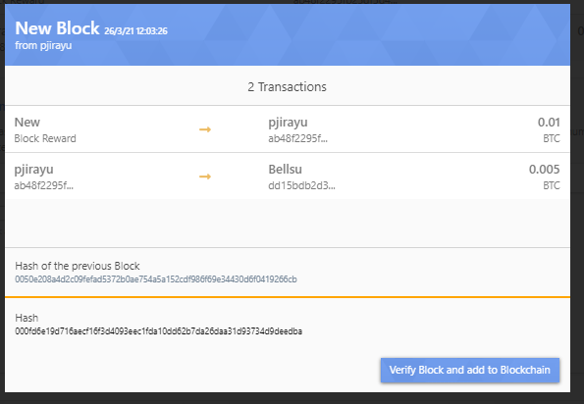

1. Create a transaction say, A to B but have it mined by C, D, E at the same time with the same transactions

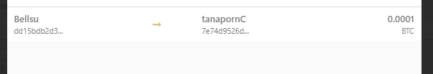

1. Create a few transactions but have it mined by C, D, E at the same time with different selected transactions from mempool.

Even though selecting some valid, it can’t make transaction. We have to be done all valid in the once time.

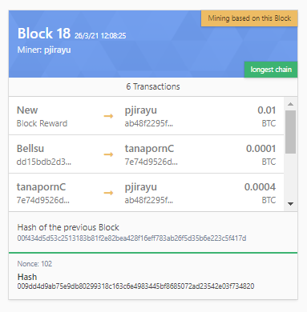

1. Create a transaction A to B, have it mined, but one of the miners say C do not add it to the blockchain. Now create another transaction and have it mined. What happens to the C’s blockchain?

No reason, only accepted by everyone unless C person

1. Create a double spending transaction – List down how you would do it.

I’m done as exercise’s group.

**For Submission as Group.**

Include the names of everyone in the submission.

List down the steps you will need to create a double spending on the Simulator. Be as clear and concise as possible.

Include images to show

1. The initial balance of those involved

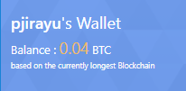

1. The transaction used to create double spending.

Both verification

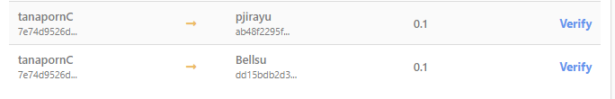

Add two transaction in one time with really insufficient funds for testing double spending.

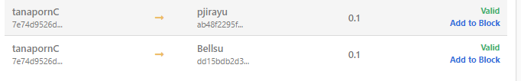



Add anyway





All transaction

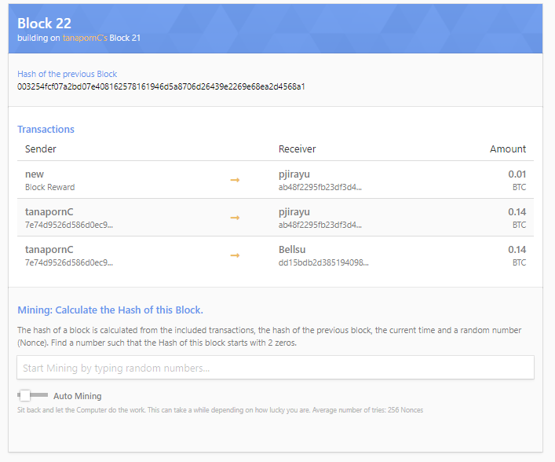

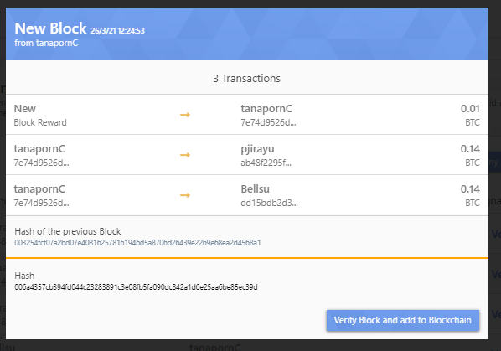

1. the final blockchain.

Can’t be done in double spending

(The final show Insufficient Fund.)

